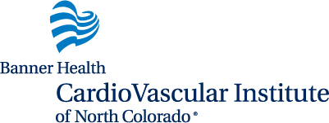

CardioVascular Institute Heart Conference
Tuesday, February 23, 2023
University of Northern Colorado Ballroom
Greeley, CO

Company Name: ___________________________________________________________________________
Company Contact, Phone, Email: ______________________________________________________________
Sponsorship Levels:
 | Platinum | Gold | Silver | Bronze
2 Free admissions to conference with breakfast and lunch
Exhibit table
Second exhibit table
Verbal recognition of your contribution during introduction and closing
Company/Produce Logo on:
Table Tents on all attendee tables
All Conference handouts
Projected on main screens before conference and during breaks
Projected on main screens during introductions
Contribution | $1,500 | $1,000 | $750 | $400
Please indicate which sponsorship level you would like. Banner Health will uphold all mentioned exhibit agreements associated with the level chosen. Any deviation from the agreed upon terms will be subject to a refund to the vendor identified.
Enclosed is a check made payable to the Weld Legacy Foundation 815 8th Avenue Greeley, CO 80631 in the amount indicated above.

